“Find My Patient V2”

(Online extension)

Software documentation



|  |  |
| --- | --- |
|  | Gerard Klomphaar  11-5-2016  EPITA |

Contents

Subject description 3

Goal 3

Use case 3

Subject analysis 4

Major features 4

Application Feasibility 4

Data description 5

Expected results 5

Algorithms study 5

[A1] Saving data 5

[A2] Searching data 5

[A3] Website Responsiveness 5

Scope of the application 5

Conception 6

Chosen algorithm 6

Data structures 6

Global application flow 6

Global schema and major features schema 6

GUI description 6

<One section by page> 6

Configuration instructions 6

Commented Screenshots 6

Bibliography 6

# Subject description

## Goal

This project is created as a mean to show sufficient knowledge of java which is acquired during the Advanced Java classes at EPITA.

During these java classes a range of technologies and best practices related to java is shown, this knowledge is implemented in this project to show sufficient knowledge about the technology and how to apply them in practice.

# Use case

As a use case a hospital patient management system is created which includes all the technologies and best practices acquired during java class. This system is an extension of the developed application during the previous java class.

The hospital management system which is created should be a web application. The main features are analyzed in the next chapter.

# Subject analysis

The minimal requirements for the system are extracted from the specification provided on the Advanced Java webpage[1]. The requirements are applied to the use case.

## Major features

The following 4 categories of features and associated requirements are extracted:

**Main application features**

1. Login page for authentication
2. Welcome page, as a sort of dashboard
   * Disconnect options, takes the user to the login page
3. Creation page
4. Search page
   * Delete option
   * Modify option

**Technology requirements**

1. Use Hibernate or JDBC to store data models

**Process requirements**

1. Use Junit to test
2. Scalability

**Additional features**

1. Make it possible to dynamically add new fields to the data model

## Application Feasibility

To determine the feasibility we will analyze the requirements and determine the risk for the realization of this requirement

|  |  |  |
| --- | --- | --- |
| Requirement | Analysis | Risk |
| [REQ1] – [REQ4] | The creation of webpages including the communication with servlets and backend processing is covered during class and can used in this project. | Low risk |
| [REQ5] | The data models are simple and Hibernate and JDBC are known technologies. | Low risk |
| [REQ6] | The context in this project is different from the learned content during class. Since we are working with Spring and JUnit on servlets this could provide issues while testing and can result in addition time spend. | Medium risk |
| [REQ7] | Scalability in the context of web development is a new area which knowledge needs to be accumulated, this can result in potential extra work | Medium risk |
| [REQ8] | The addition of new fields in a web application is an unknown area, since the data models are static, additional technologies or methods need to be researched. This will probably result in lots of effort. | High risk |

## Data description

The project mainly manages patient data, additional there is User data which will be used for authentication. Below the two data types are displayed.

|  |  |
| --- | --- |
| Patient | |
| Field | **Type** |
| Id | int |
| First name | String |
| Last name | String |
| Social security number | String |
| Telephone number | String |
| Email | String |
| Room | String |

|  |  |
| --- | --- |
| User | |
| Field | **Type** |
| Id | int |
| Name | String |
| Password | String |
| Rights | int |

## Expected results

The result of this project should contain the features and extracted requirements. There should be documentation which is clear enough to get the main idea of the application and its structure.

## Algorithms study

The different possibilities to realize certain functions are analyzed to result in the best applicable solution

### [A1] Saving data

To the two data models User and Patient previously a specific DAO implementation is used. This implementation could handle different data models, but cannot handle dynamic data. Since the application should be scalable [REQ 7], it is preferred to have a more dynamic solution. Hibernate can be a better solution to provide this [REQ 5].

### [A2] Searching data

The application should feature a search method. Since the data should be scalable [REQ 7] & [REQ 8], the search should be able to handle dynamic fields.

### [A3] Website Responsiveness

It should be able to do operations on Patients like create, modify and delete without unnecessary page reloads.

### [A4] Packaging & Architecture

The different features required should be organized in a way that is maintainable. The basic functionality from the previous java semester can be used where necessary.

### [A5] Authorization & Security

To provide security an authorization mechanism should be provided. The mechanism of the previous project will be used. A method should be created to save the User credentials and status for each connected in parallel.

### [A6] Software configuration management

To control the different version of the used packages a system needs to be used.

## Scope of the application

The application is restricted to the features specified in chapter *Major features.*

Additional features which are **out** of scope:

* The graphical design of the website (basics representation be implemented).
* Additional security: e.g. encryption of the http session, encryption of saved User data.

# Conception

This chapter provides the chosen design for the application

## Chosen algorithm

### [A1] Saving data

Saving data is done using the hybernate technology, this ensures the flexibility required

### [A2] Searching data

To search data based on the potential dynamic fields of the data models, a custom where clause generation feature will be created. This clause can then be used with the chosen hybernate technology to execute the search. In *Figure* 1 the sequence of searching using the “WhereClauseBuilder” is depicted.

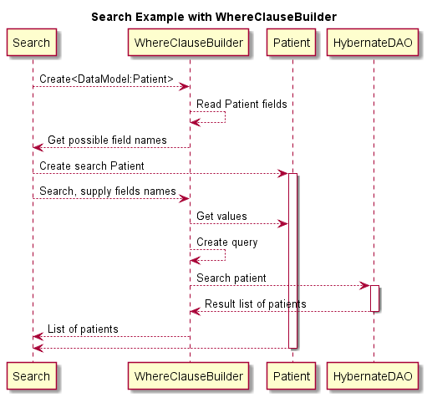

Figure 1 - Where clause sequence

### [A3] Website Responsiveness

To provide a responsive flow to the user without unnecessary refreshes of pages the AJAX technology will be used.

Sending data between Pages and servlets will be done using JSON objects. This provides an efficient and scalable solution for data transfer.

Figure 2 depicts the sequence which is used for modifying a Patient.

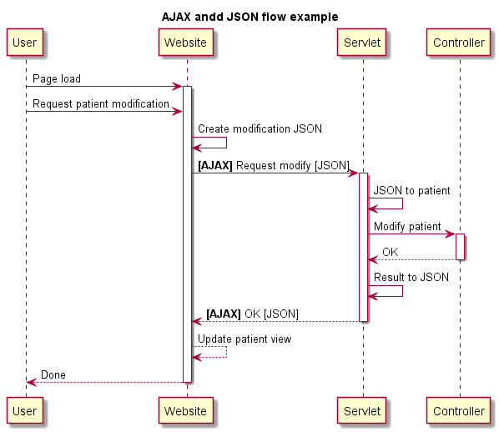

Figure 2 - AJAX usage for patient modification

### [A4] Packaging & Architecture

To organize the different features the project is subdivided in the packages shown below, each package is a project.

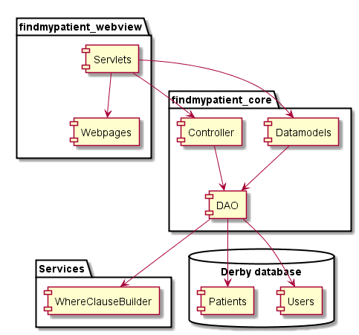

### [A5] Authorization & Security

To provide authorization for each individual connected user each user will have an individual Controller assigned. The controller which also has the authentication functionality is saved in the http session with the user.

To provide additional security, no additional content or pages can be accessed without logging in. Any post or get functionality will not work without a login.

A future improvement would be to encrypt the HTTP session and to encrypt the password which is currently saved as a raw string in the database.

### [A6] Software configuration management

#### Maven

To provide a configuration environment Maven is used. The project will comply with the company versions specified in the company Maven “super POM”.

#### Spring

To provide a flexible software application the dependency injection framework Spring is used. Interfaces will be created to be able to inject different implementations.

## Global application flow

The global application flow is based on the specified requirements [REQ 1-4]. The flow is depicted below:

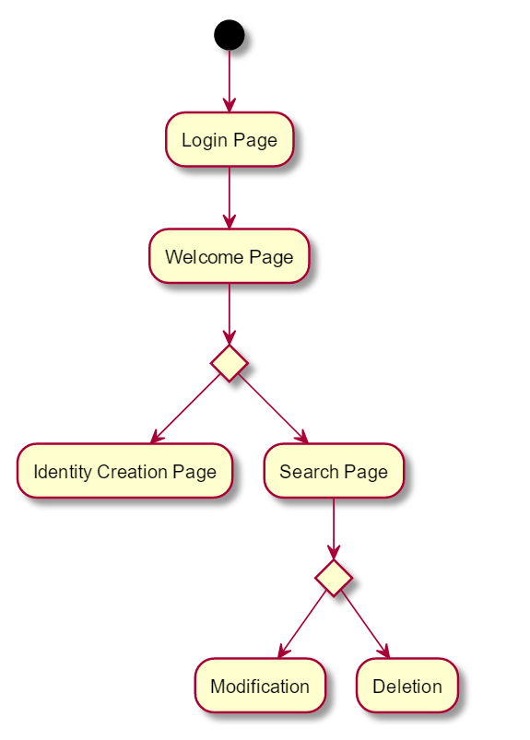

## Global schema and major features schema

# GUI description

## LOGIN

At first access to the webpage the backend database will still be empty. This will result in the display of a configuration page *Figure* 1. Through this page the initial administrator can be created. After creation any following access will display the login page *Figure* 2.

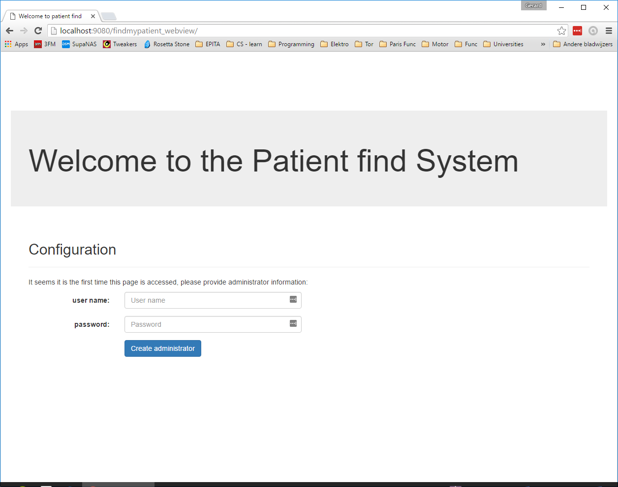

Figure 3 - Configuration page

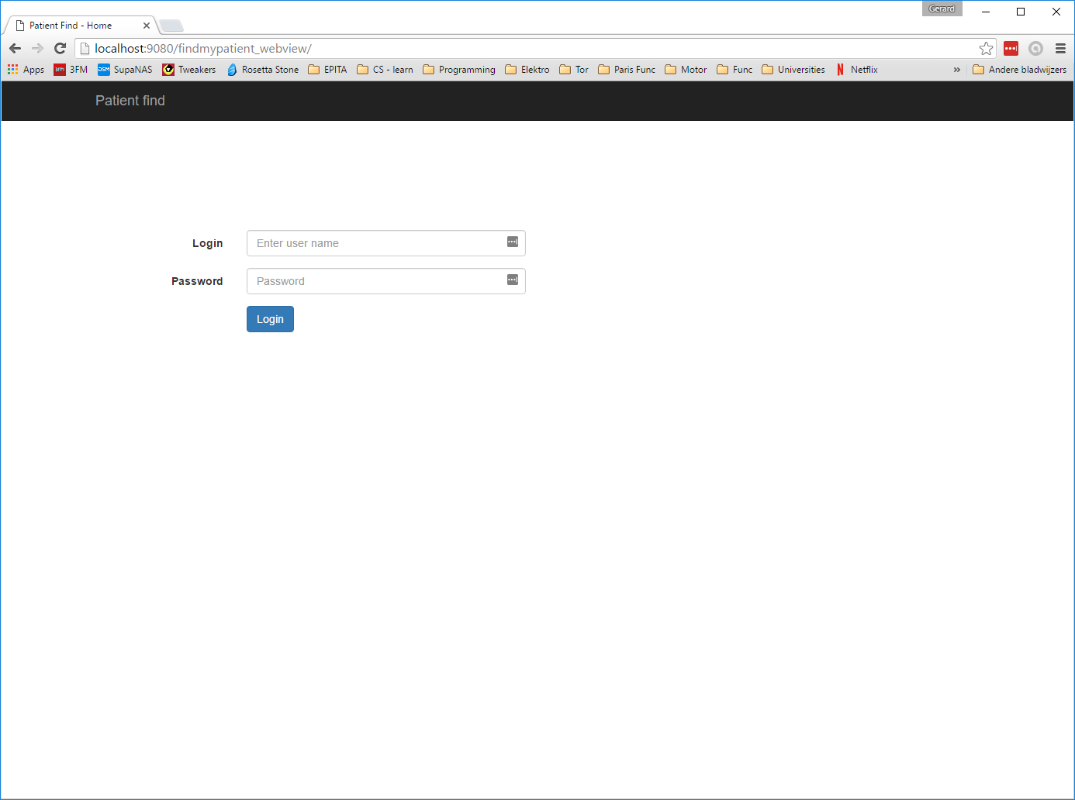

Figure 4 - Login page

After login a welcome page will be displayed *Figure* 5, which gives access to creating new patients or show the current patients. At the top of the screen the navigation bar can also be used. At the top right the logout option is can be found.

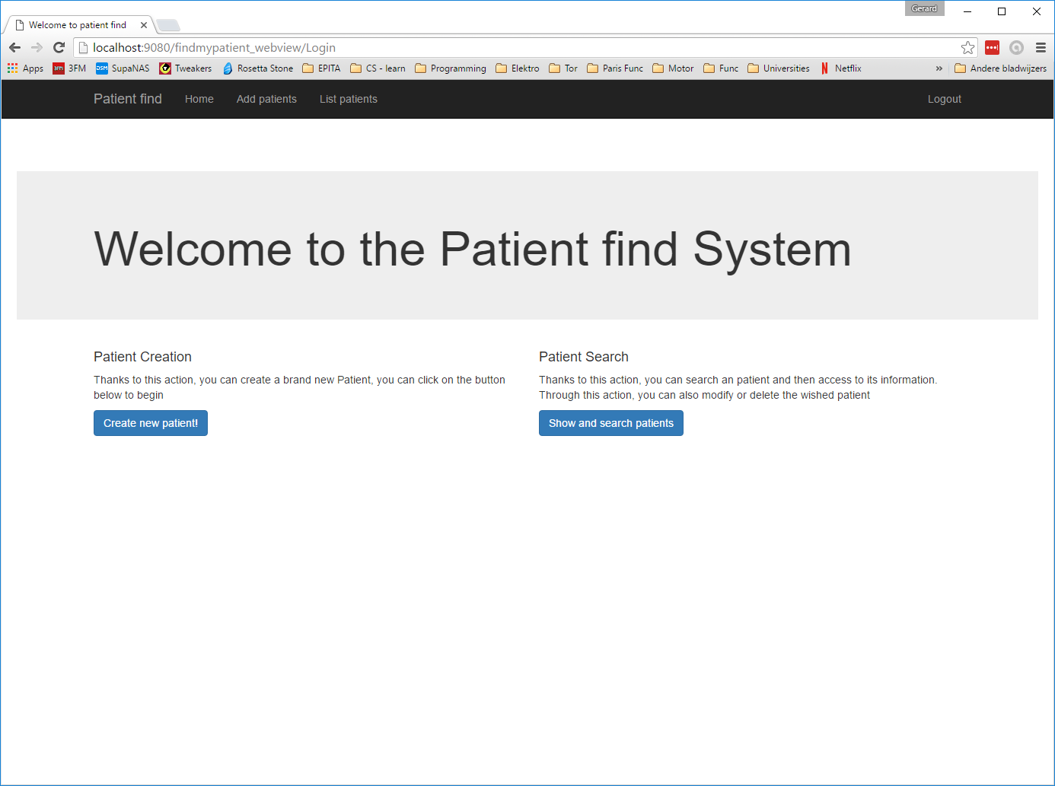

Figure 5 - Welcome page

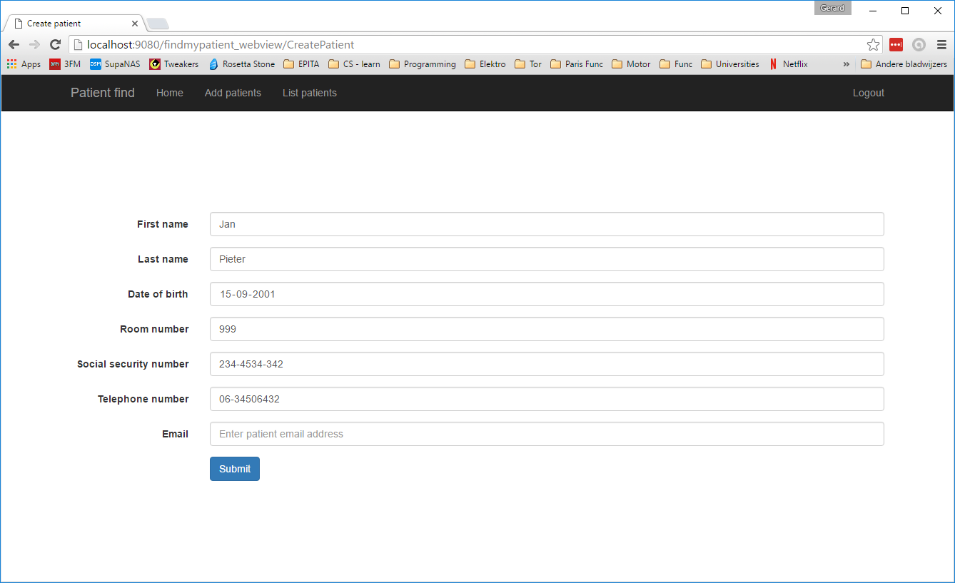

Figure 6 - Create pation page

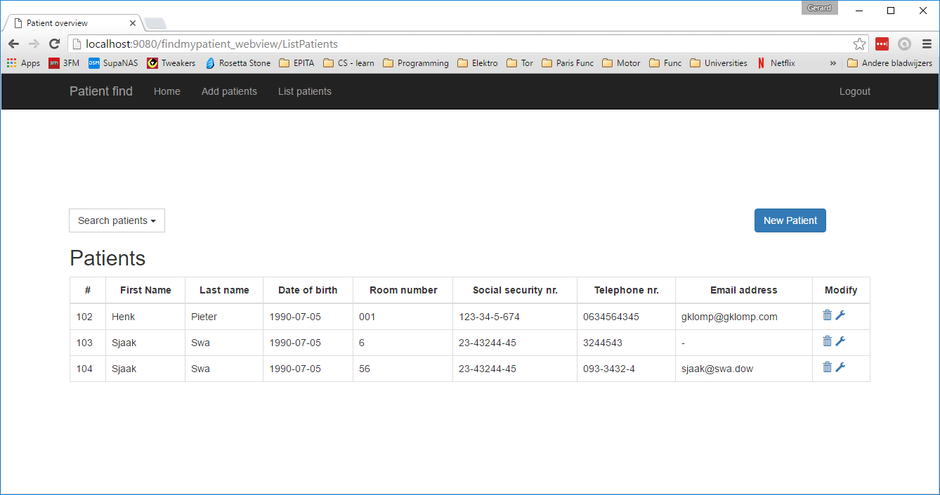

Figure 7 - Patien overview page

In the “list patients” page search actions can be executes. Multiple parameters can be combined in a single search.

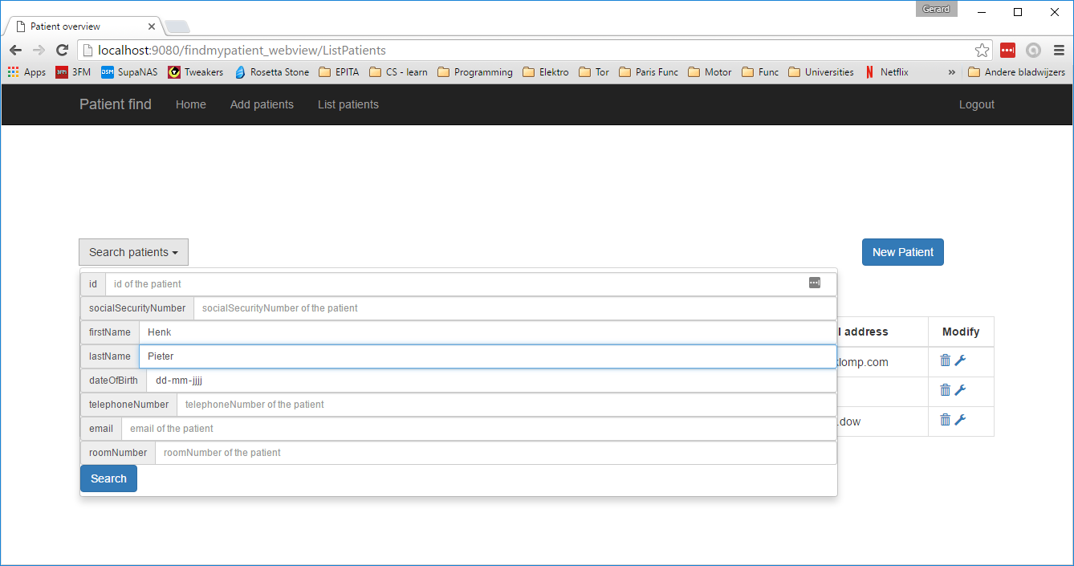

Figure 8 - Search patients action

At the right of each patient in the patient overview list 2 actions are displayed, delete and modify. Both will pop up a new window in which the actions can be confirmed. *Figure* 10 & *Figure* 11

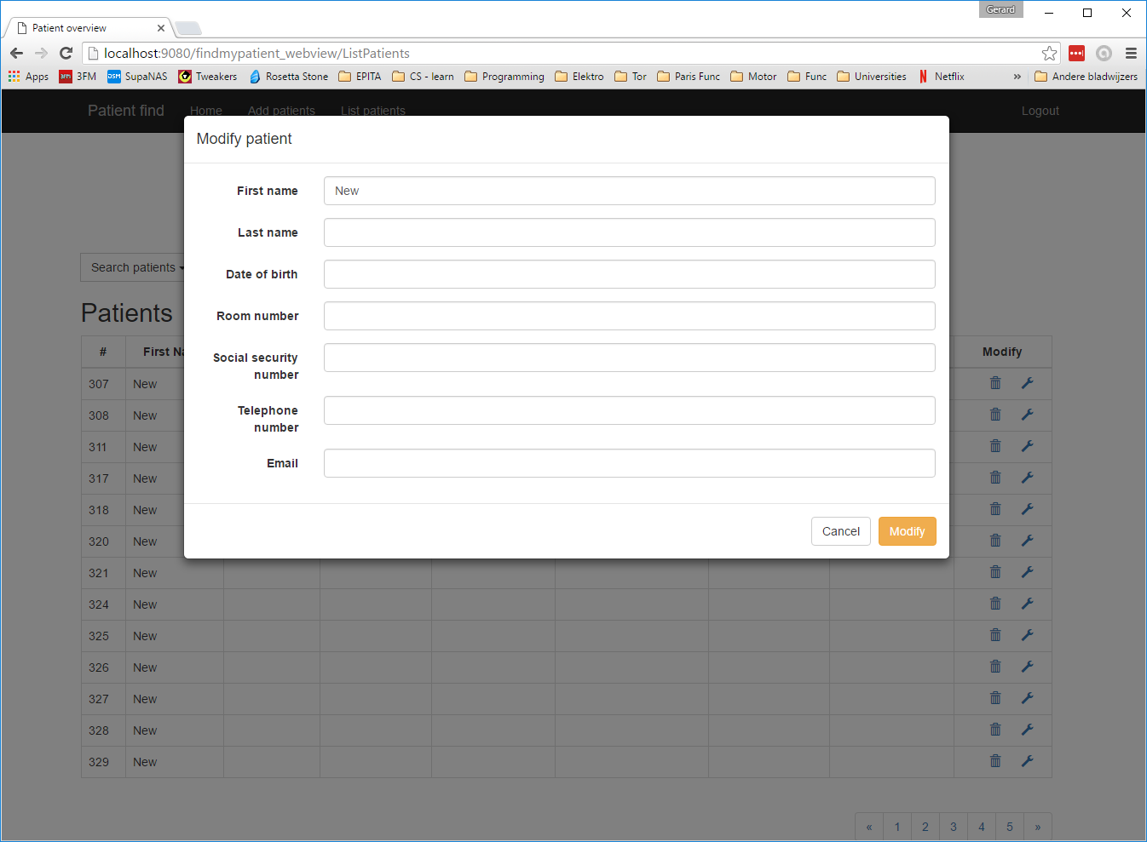

Figure 10 - Modify patient action

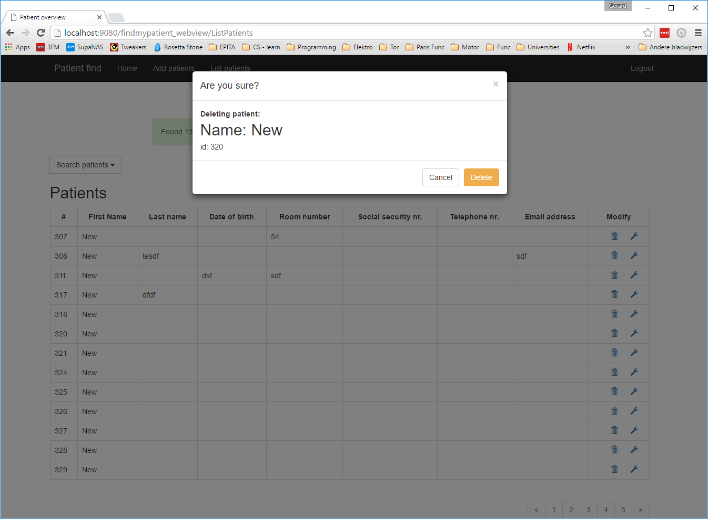

Figure 11 - Delete patient action

# Configuration instructions

## Database configuration

The database is run as a derby in memory database. It is a persistence version and the location is: ‘PatientsDB’ (url:*"jdbc:derby:****PatientsDB****;create=true")*. It is tested with a Tomcat v7.0 server. If preferred above url can be changed in ”applicationContext.html”. The ***PatientsDB*** part can be replaced with an absolute path, e.g. *"jdbc:derby:****C:/PatientsDB****;create=true")*.

## Open in browser

The website is generally run on: http://localhost:”*configuratedPort”*/findmypatient_webview

1. <http://www.thomas-broussard.fr/work/java/courses/project/advanced.xhtml>